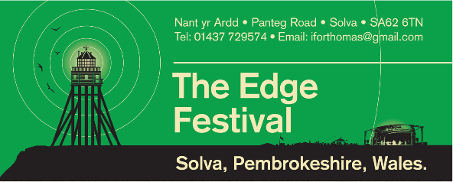
Hello,

Welcome to the Edge Festival, a community festival based in the beautiful village of Solva, a celebration of the Arts, Literature, Music, Sport and Food. Following on from the success of our previous festivals the Edge is returning in August 2017 and we want YOU to join us!

We had over 30 different businesses and stall holders over the weekend of the festival in 2016 and we’re hoping to make 2017 even bigger! With over 3500 people attending the festival over 3 days we know we have a unique and exciting opportunity for your business.

- Each stallholder will be given a designated pitch (inside a marquee if required) for the duration of the weekend with the main market day on Saturday for a £40 fee you will guarantee your place at the Edge.
- All food vendors can buy a pitch for £100, this will guarantee your pitch for the entire weekend.
- Each ‘pitch’ consists of a table, enough room for storage and of course an exciting opportunity to be part of the festival.
- Anyone wishing to take up a pitch must give us a completed fire safety and risk assessment for their relevant business etc
- All safety of stock and goods is the responsibility of the stall holder and the Edge Festival takes no liability for any stock or goods.
- A non refundable deposit of 25% will be taken to secure your pitch.
- Any stall holder wishing to use an alternative supply of power or generator MUST inform us of their intention and give relevant information relating to generator etc.
- 50% discount for local residents of Solva (does not apply to food vendors).
The Edge is a unique event bringing together the best of local talent and local producers to provide a fun filled and diverse weekend of great events. There is something for everyone at the Edge and we’re proud to be returning with a weekend of great live music, literature and poetry, food demonstrations, nature walks and Wales’ only open water swim. So be part of something exciting in 2017 and join us on the Edge!

Thanks

Edge Festival Retail and Market Manager

Becky Ricketts

